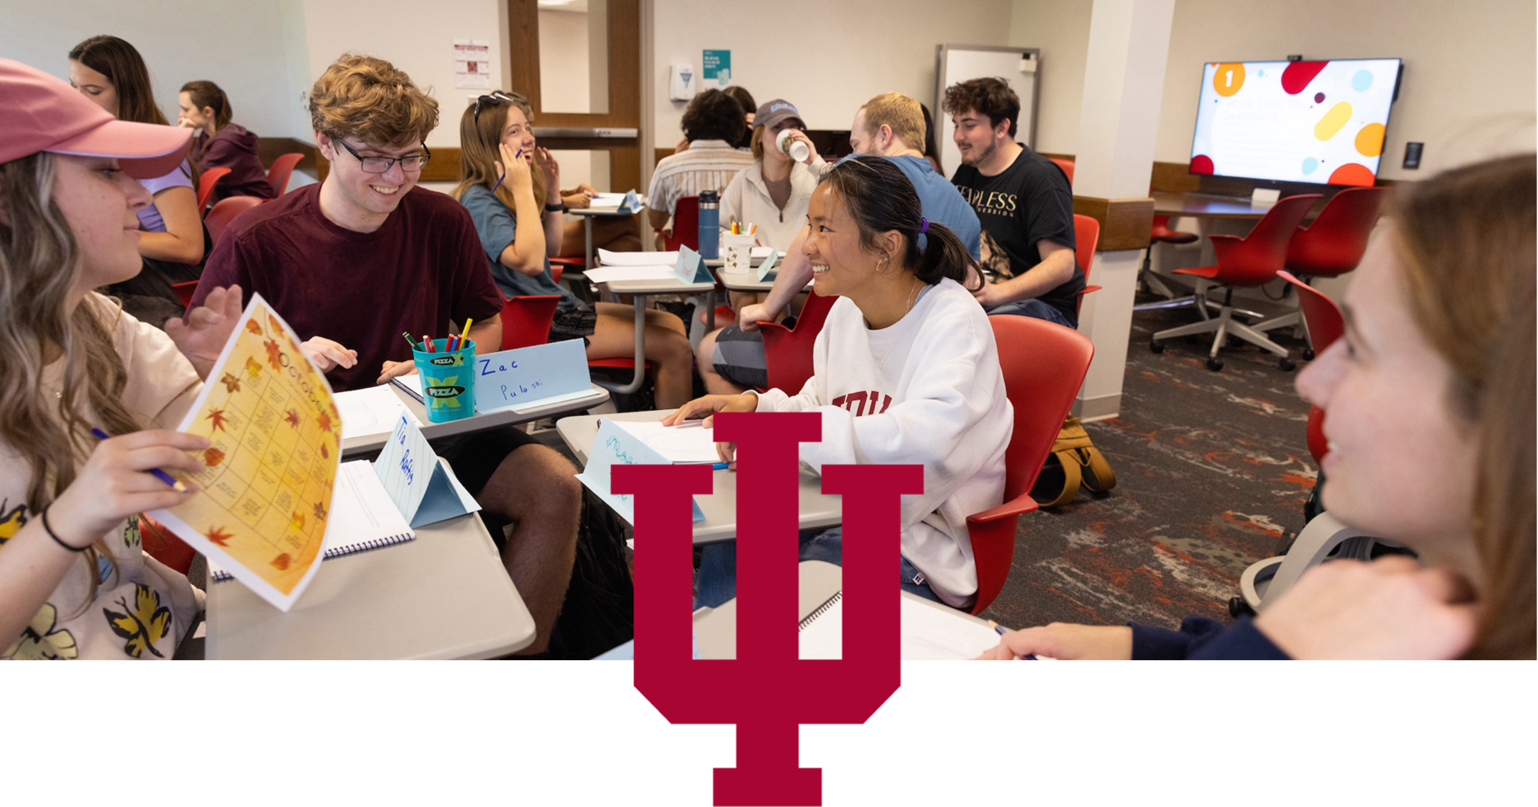

ANNUAL REPORT 2024-2025
TRANSFORMING STUDENT FUTURES

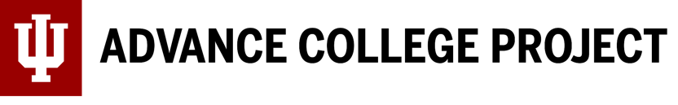


LETTER FROM THE DIRECTOR
TROY BYLER
DIRECTOR, ADVANCE COLLEGE PROJECT
Dear friends and partners,
The Advance College Project (ACP) provides select IU undergraduate courses to well-prepared students in the high school setting. ACP-trained high school instructors administer the IU courses with fidelity to the quality and rigor as found on campus, while faculty liaisons and site visitors observe ACP classrooms, approve syllabi, and provide ongoing feedback. This leads to more students completing IU undergraduate degrees within four years.
ACP instructors are required to have a master’s degree in the content area or an outside master’s with at least 18 graduate hours in the dual credit discipline. In support of our current and future instructors to meet this requirement, we created the IU Dual Credit Pipeline, where we used state-appropriated funds to cover tuition for our Indiana instructors enrolled in IU graduate courses. We are pleased to share evidence of their progress in completing this graduate work.
Our collaboration with IU faculty, high school instructors, and the Indiana Commission for Higher Education, allows more students to complete the Indiana College Core through IU and achieve academic success at the post-secondary level. In addition to the information found in this report, you can learn more about our goals, course offerings, and policies by visiting acp.iu.edu and exploring the student and instructor handbooks.



BENEFITS TO ACP STUDENTS
ACP conducted a survey with project alumni in the high school graduating classes from 2019 to 2022. Here's what they had to say about the program:
PRACTICAL BENEFITS
Cost effectiveness, getting ahead before beginning college

ACADEMIC BENEFITS
Smaller classes, deeper thinking, college credit without AP exams

MENTAL HEALTH BENEFITS
Easing transition to college, feeling more prepared, developing comfort in college classes in high school, no stress resulting from AP exams

OUR PARTNERS’ EXPERIENCES
"A smaller class setting allowed me to get to know my professor. I was pushed to a higher standard of work which helped me transition into my freshman year of college."
"I liked the more open discussion-based and big projects instead of busy work."

“I liked how my teachers taught the courses like an actual college class but slowed it down to help me to better understand it."
"The Advance College Project (ACP) through Indiana University has given our faculty a pathway to becoming credentialed instructors, which in turn has opened up tremendous opportunities for Frontier students. Our students can graduate with several semesters of college credit - allowing them to get a head start on life."
"I loved the dual credit aspect. I felt that I was truly learning rather than preparing for an AP test. I would recommend ACP to any current high schooler."
“At Ben Davis High School, we love our partnership with the IU ACP program. Our students are earning college credits from a preeminent university while in high school. Our teachers are growing as they work with IU professors to develop and hone their craft. Our admin team enjoys the amazing relationship we have built with the IU ACP staff.”

WE PROVIDE THE DIFFERENCE
Although ACP, AP (Advanced Placement), and other dual credit providers can provide college credit to high school students and expose them to demanding curricula, there are significant differences.
(Fall 2024) | ACP | AP | Other Dual Credit
Number of IU beginner students total | 7,988 | 7,988 | 7,988
Students with selected hours | 2,978 | 2,506 | 3,774
Hours by selected category | 21,595 | 28,325 | 79,858
Average hours per student | 7.3 | 11.3 | 21.2
Credit hours brought into IU | 21,595 | 28,325 | 79,858
Enrollment | IU course enrollment for high school credit | High school course, college credit based on exam score | Non-IU course enrollment for high school credit
Instructors | IU faculty-trained high school instructors | High school instructors encouraged to participate in training | Non-IU trained high school instructors
Professional Development | IU faculty-led annual workshop | Fee-based corporate-led workshop | Non-IU annual workshop
IU-funded graduate Courses/Degrees for HLC compliance | Yes | No | No

ACP BY THE NUMBERS
From the 2023-2024 academic year to the 2024-2025 academic year, the total number of enrolled ACP students increased by 1,985. Over this same period, total annual ACP enrollments increased by 5,252 and total IU credit hours earned through ACP increased by 12,939.
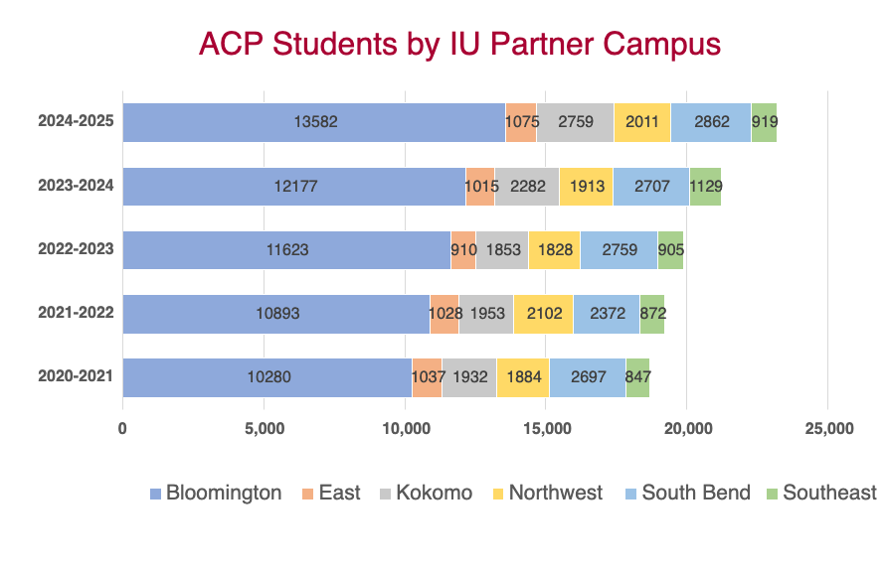

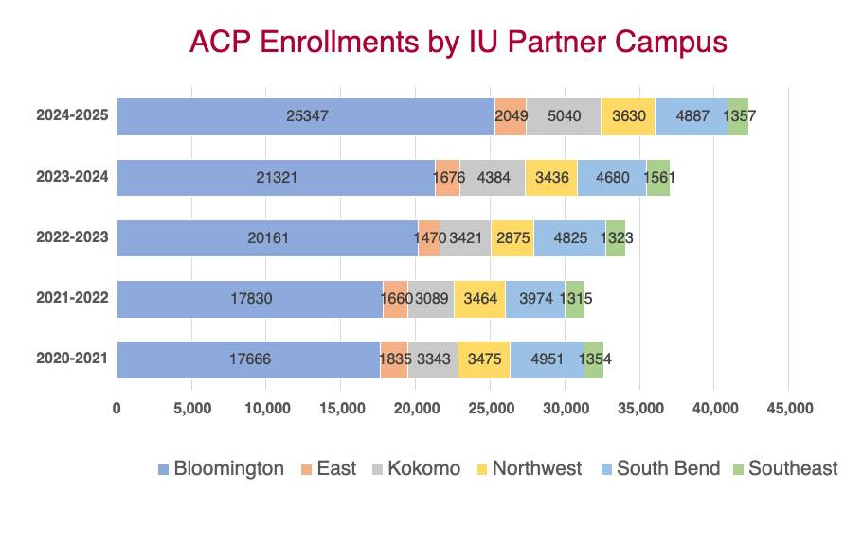
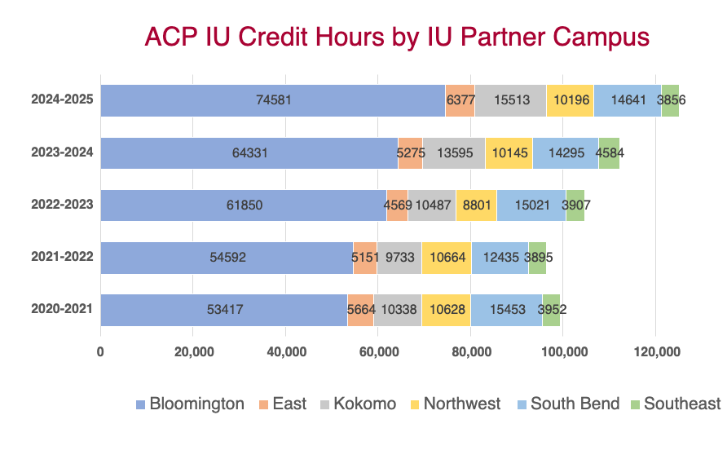

ACP INSTRUCTORS
ACP courses are taught by specially trained high school educators who meet the professional and academic expectations of the on-campus department and the Higher Learning Commission. In turn, instructors are given access to IU resources such as libraries, databases, Canvas and more.
ACP equips instructors to teach IU curriculum and university learning outcomes in high school classrooms. IU coursework taught through ACP is designed to enhance critical thinking with goals that are relevant and timely with real-world applicability. ACP also provides professional development opportunities through IU campuses.
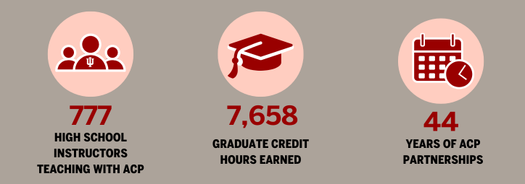
“. . .College faculty bear primary responsibility for ensuring that concurrent enrollment course content, assessments, and expectations are of comparable quality, and that institutions must provide adequate resources to support faculty in fulfilling this responsibility.”
Source: NACEP Accreditation Guide
PREPARING FOR POST-SECONDARY SUCCESS

INDIANA COLLEGE CORE

The Indiana College Core (ICC) is a general education certificate of 30 college credit hours that transfers between all Indiana public colleges and universities, and many private institutions that have opted in.
To earn the certificate, students must earn 30 credits in six competency areas, with 15 of the credit hours through IU courses and a minimum cumulative 2.0 GPA for all ICC courses. In 2024-25, seven IU campuses offered the ICC – Bloomington, East, Indianapolis, Kokomo, Northwest, South Bend, and Southeast. An ICC coordinator at each campus leads efforts to build partnerships with high schools and implement the ICC.
In 2024-25, IU added 15 new high school partnerships and the number of students earning the ICC more than doubled from 2023-24.
THE ICC FRAMEWORK
The ICC is based on competencies and learning outcomes in six areas from two categories. The categories are Foundational Intellectual Skills (Quantitative Reasoning, Speaking and Listening, and Written Communication) and Ways of Knowing (Humanistic and Artistic, Scientific, and Social and Behavioral).
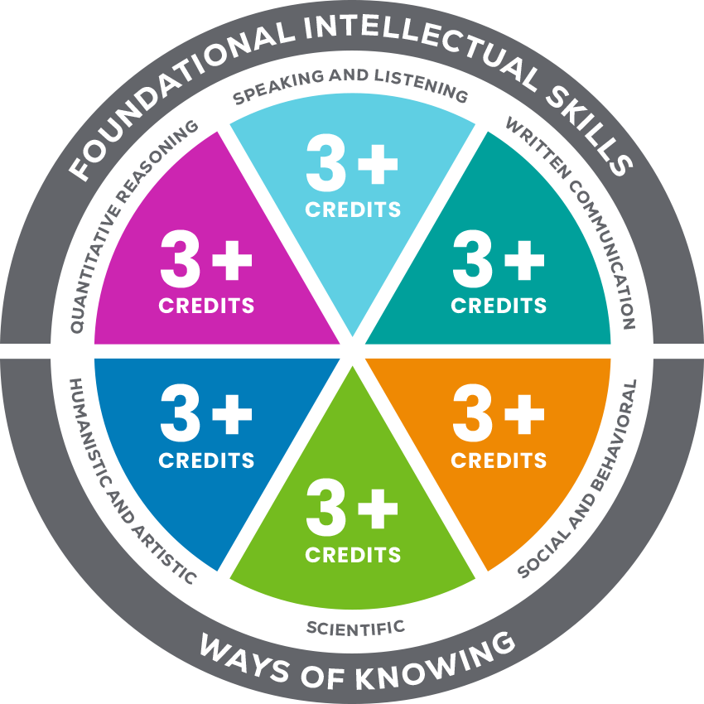
WHERE THE ICC IS OFFERED
MYCOLLEGECORE.ORG/ABOUT/WHERE-CAN-I-EARN-IT
NUMBER OF HIGH SCHOOL PARTNERS 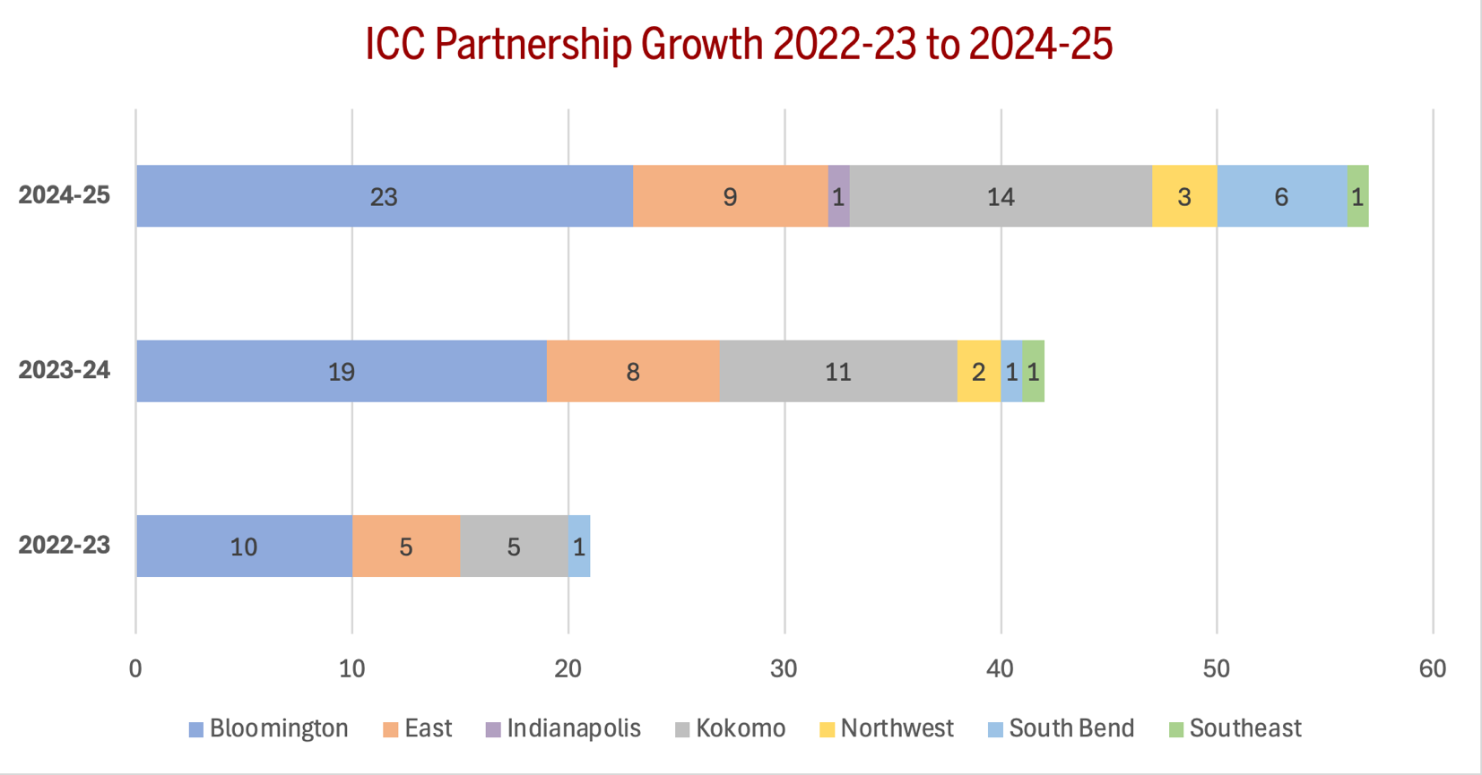
NUMBER OF ICC EARNERS
